REF. LIST OF CLEAN AGENT SUPPRESSION SYSTEM

|  |  |  |  |  |  |
| --- | --- | --- | --- | --- | --- |
| S,NO | PROJECT | CLIENT | CONSULTANT | PROTECTED AREAS | PRODUCTYEAR |
| 3 | IBM Data Center | IBM | IBM | **IBM Data Center** | INERT/2002 |
| 5 | Dubai media city phase 3 | TEECOM | TIM & PARTNER | 33 AREAS | IG100 |
| 7 | Dubai World Trade Centre (WTC) | Emaar Properties | RMJM | Computer Room | INERT |
| 16 | FUJAIRAH electricity and water | **FEWA** | LAHYMER | 19 AREAS | INERT |
| 17 | Sharjah Electricity and power | SEWA | CANSULT | 4 AREAS | INERT |
| 19 | [Standard Chartered](http://www.standardchartered.com/home/en/index.html) | BANK | TOM INT'L | DATA CENTER | INERT |
| 21 | Dubai Municipality | Dubai Municipality | DIRECT | Pesticide stores | Nitrogen |
| 25 | Gulf Library/archive Manuscript | PWD /A/Dhabi | AL BURJ | MISC ROOMS 23 | INERT |
| 27 | **Adwea control center Bldg** | **Adwea** | [WSP Group – engineering consultants](http://www.wspgroup.com/en/) |  | INERT |
| 28 |  |  |  |  |  |
| 29 | A.Power Distribution Company. | **AADC** | white young | 09 AREAS /GOING ON | INERT |
| 32 | Dubai .M H.Q Environment sect | Municipality | Municipality | 06 areas | NAF S 125 |
| 33 | Dubai Municipality Library | direct | Direct | 4 | NAFS 125 |
| 34 | Sc bank Data center in Difc | Municipality | municipality | 01 AREA | Nitrogen |
| 36 | Etisalat Telecom Bar dubai | **ETISALAT** | AL SUWAIDI | 11 AREAS | IG100 |
|  |  |  |  |  |  |
| 38 | Canar telecom sudan | sudan | Canar / Etisalat | 06 areas | *FM200/42 bar* |
| 40 | DU Telecom | DU | DU | 02 areas | Nitrogen |
| 41 | Islamic Museum Sharjah | shj Govt | WSP | 10 areas | Nitrogen |
| 42 | Dewa Sub station | dubai Govt | Many | 73 sub stations | Inert Gas |
| 43 | DIFC DATA CENTER | Difc | Schnabel | 11 areas | Inert Gas |
| 47 | **Masdar city** | ETA | Halbro | 08 areas | Inert gas |
| 54 | Metro - | Hitachi Technologies | http://www.atkinsdesign.com/html/images/atkins_logo.gif | 55 areas | *FM200* |

**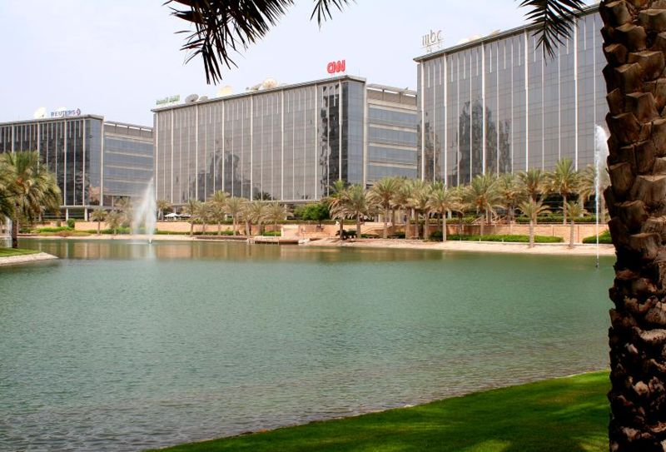**

DUBAI MEDIA CITY

**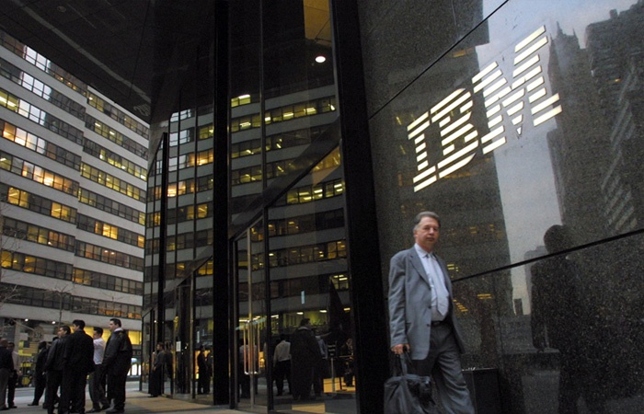**

IBM DATA CENTER

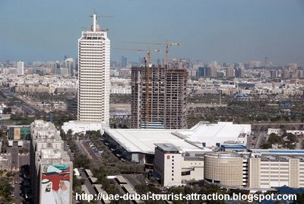

DUBAI WORLD TRADE CENTER (WTC)

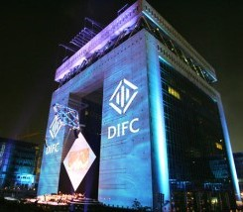

DIFC DATA CENTER

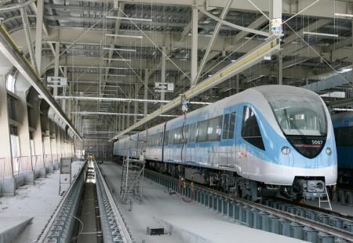

DUBAI METRO

**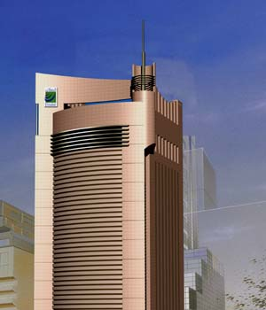**

(BUR DUBAI BLDG)

[Etisalat Logo](http://www.etisalat.ae/index.jsp?lang=en)

**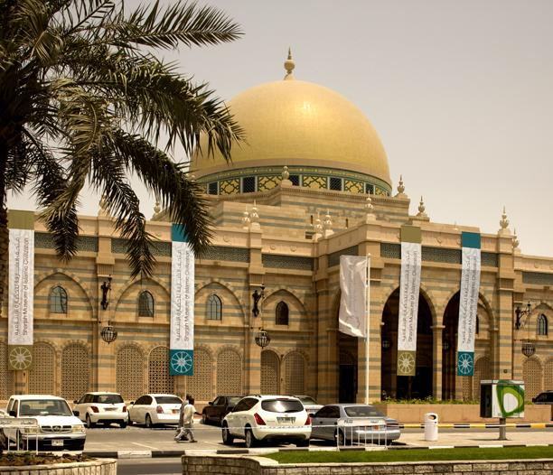**

ISLAMIC MUSEUM SHARJAH

**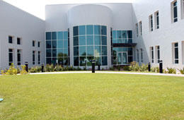**

LIBRARY

[بوابة بلدية دبي](http://login.dm.gov.ae/wps/portal/HomeAr)

**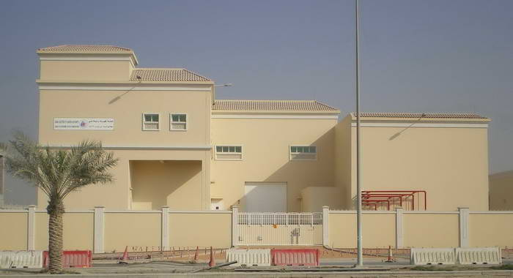**

**[](http://www.dewa.gov.ae/arabic/)**

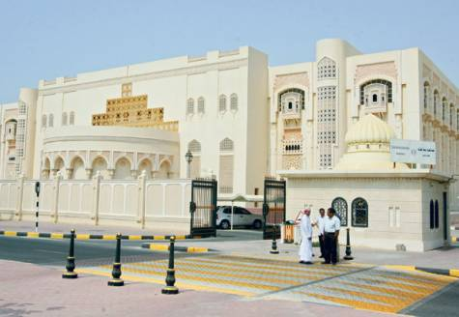

SHARJAH ELECTRIC CITY WATER AUTHORITY

**C:\Users\Touchmate\Desktop\sewa_logo.gif**

****

Adwea control building

Consultant : White young / WSP



Gulf library and Manuscript - Abu Dhabi

C:\Users\Touchmate\Desktop\emiratesNBDLogo.jpg

Al Barsha Data center

[http://www.masdar.ae/en/images/logo.gif](http://www.masdar.ae/en/home/index.aspx) 

Inert Gas system supplied as it is clean concept city Sudan Telecom / Etisalat / Fm200

[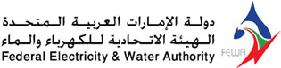](http://www.fewa.gov.ae/index_en.html)